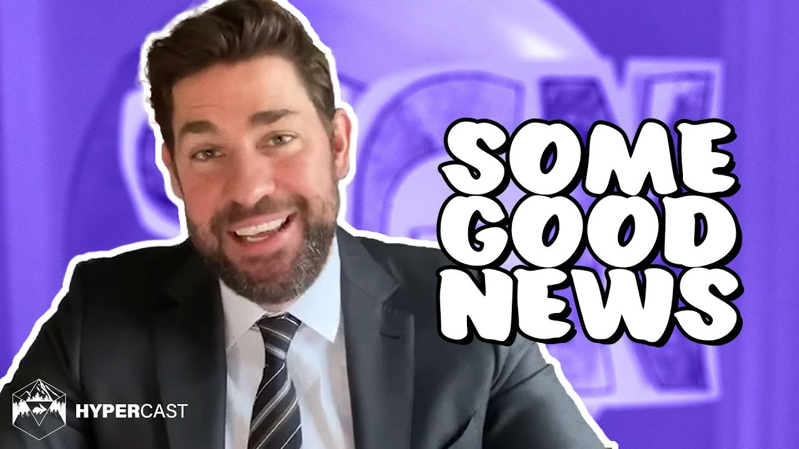
“Some Good News with John Krasinski”
Skills: Presentation, voice, research- DUE FRIDAY May 29, 2020
https://youtu.be/F5pgG1M_h_U
Your show will be humorous, positive, light and entertaining for all ages!
What should be in my Newscast show?
- 2-4 good news stories (found online or things happening at home)
- 1 creativity share (can you roll your tongue?, sing a song?, or show us how you can make your dog roll over, dribble a soccer ball etc.???)
- ***** Optional: 1 interview of a family member at home or recorded with a friend online
What do I need to create?
- Create a newscaster character that you will play
- Design or create your own News Sign/ Logo
- Design your own News Desk ( use a table or desk you have- just set it up to look professional for the show)
- Include Music for the beginning and end of your show
- Include sound effects in between stories, or as happy news comes up, to alert your audience of its importance.

- Do I need specific software to do this?-
NO, you can use Chromebook or phone to create this newscast, just be sure to practice/rehearse prior to filming so there are no long pauses…audiences do NOT like waiting! Do what works for you and whatever you can use to send it to me at Jmcvicar@wcskids.net
- Can my family help me with this?
Absolutely! The more the merrier. In fact, adding a cast of characters can give this value and depth!

***** The above link is to one of the first episodes, but I believe he has done 7 or 8 at this point. So, take a few minutes to watch a few different episodes to get ideas and HAVE FUN!

